**Lab 21: Async Task using Java**

This example demonstrate about how to use asyncTask in android.

**Step 1** − Create a new project in Android Studio, go to File ⇒ New Project and fill all required details to create a new project.

**Step 2** − Add the following code to res/layout/activity_main.xml.

<?xml version = "1.0" encoding = "utf-8"?>

<LinearLayout xmlns:android = "http://schemas.android.com/apk/res/android"

   xmlns:tools = "http://schemas.android.com/tools"

   android:id = "@+id/rootview"

   android:layout_width = "match_parent"

   android:layout_height = "match_parent"

   android:orientation = "vertical"

   android:background = "#c1c1c1"

   android:gravity = "center_horizontal"

   tools:context = ".MainActivity">

<Button

   android:id = "@+id/asyncTask"

   android:text = "Download"

   android:layout_width = "wrap_content"

   android:layout_height = "wrap_content" />

<ImageView

   android:id = "@+id/image"

   android:layout_width = "300dp"

   android:layout_height = "300dp" />

</LinearLayout>

In the above xml we have created a button, when user click on the button it going to download image and append image to imageview.

**Step 3** − Add the following code to src/MainActivity.java

package com.example.andy.myapplication;

import android.app.ProgressDialog;

import android.graphics.Bitmap;

import android.graphics.BitmapFactory;

import android.os.AsyncTask;

import android.os.Bundle;

import android.support.v7.app.AppCompatActivity;

import android.view.View;

import android.widget.Button;

import android.widget.ImageView;

import java.io.IOException;

import java.io.InputStream;

import java.net.HttpURLConnection;

import java.net.URL;

public class MainActivity extends AppCompatActivity {

   URL ImageUrl = null;

   InputStream is = null;

   Bitmap bmImg = null;

   ImageView imageView= null;

   ProgressDialog p;

   @Override

   protected void onCreate(Bundle savedInstanceState) {

      super.onCreate(savedInstanceState);

      setContentView(R.layout.activity_main);

      Button button=findViewById(R.id.asyncTask);

      imageView=findViewById(R.id.image);

      button.setOnClickListener(new View.OnClickListener() {

         @Override

         public void onClick(View v) {            AsyncTaskExample asyncTask=new AsyncTaskExample();

            asyncTask.execute("**https://www.bpstilwari.in/bps.JPG**");         }

      });

   }

   private class AsyncTaskExample extends AsyncTask<String, String, Bitmap> {

      @Override

      protected void onPreExecute() {

         super.onPreExecute();

         p = new ProgressDialog(MainActivity.this);

         p.setMessage("Please wait...It is downloading");

         p.setIndeterminate(false);

         p.setCancelable(false);

         p.show();

      }

      @Override

      protected Bitmap doInBackground(String... strings) {

         try {

            ImageUrl = new URL(strings[0]);

            HttpURLConnection conn = (HttpURLConnection) ImageUrl.openConnection();

            conn.setDoInput(true);

            conn.connect();

            is = conn.getInputStream();

            BitmapFactory.Options options = new BitmapFactory.Options();

            options.inPreferredConfig = Bitmap.Config.RGB_565;

            bmImg = BitmapFactory.decodeStream(is, null, options);

         } catch (IOException e) {

            e.printStackTrace();

         }

         return bmImg;

      }

      @Override

      protected void onPostExecute(Bitmap bitmap) {

         super.onPostExecute(bitmap);

         if(imageView!=null) {

            p.hide();

            imageView.setImageBitmap(bitmap);

         }else {

            p.show();

         }

      }

   }

}

In the above code we are downloading image using asyncTask and appending image to imageview.

**Step 4** − Add the following code to manifest.xml

<?xml version = "1.0" encoding = "utf-8"?>

<manifest xmlns:android = "http://schemas.android.com/apk/res/android"

package = "com.example.andy.myapplication">

   <uses-permission android:name = "android.permission.INTERNET"/>

   <application

      android:allowBackup = "true"

      android:icon = "@mipmap/ic_launcher"

      android:label = "@string/app_name"

      android:roundIcon = "@mipmap/ic_launcher_round"

      android:supportsRtl = "true"

      android:theme = "@style/AppTheme">

      <activity android:name = ".MainActivity">

         <intent-filter>

            <action android:name = "android.intent.action.MAIN" />

            <category android:name = "android.intent.category.LAUNCHER" />

         </intent-filter>

      </activity>

   </application>

</manifest>

In the above AndroidManifest.xml file we have added internet permission to access internet to download image.

Let's try to run your application. I assume you have connected your actual Android Mobile device with your computer. To run the app from android studio, open one of your project's activity files and click Run Eclipse Run Icon icon from the toolbar. Select your mobile device as an option and then check your mobile device which will display your default screen.

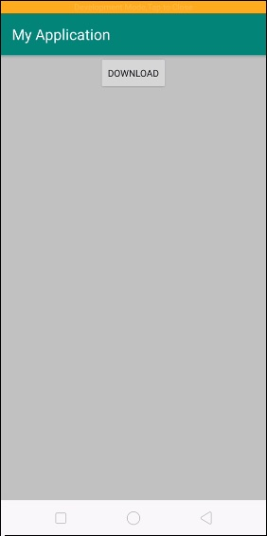

Now click on download button it will show progress on UI and download image at background as shown below

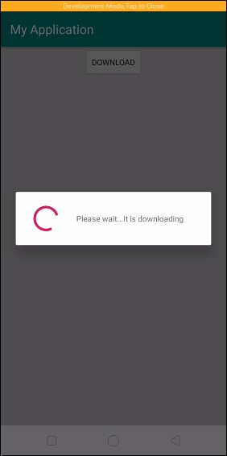

After downloading image, it will update on UI as shown below

